Development of the Stomach

Formation and initial position
The stomach appears at week 4 as a fusiform dilation of the caudal foregut, initially oriented in the median plane with its long axis craniocaudal.
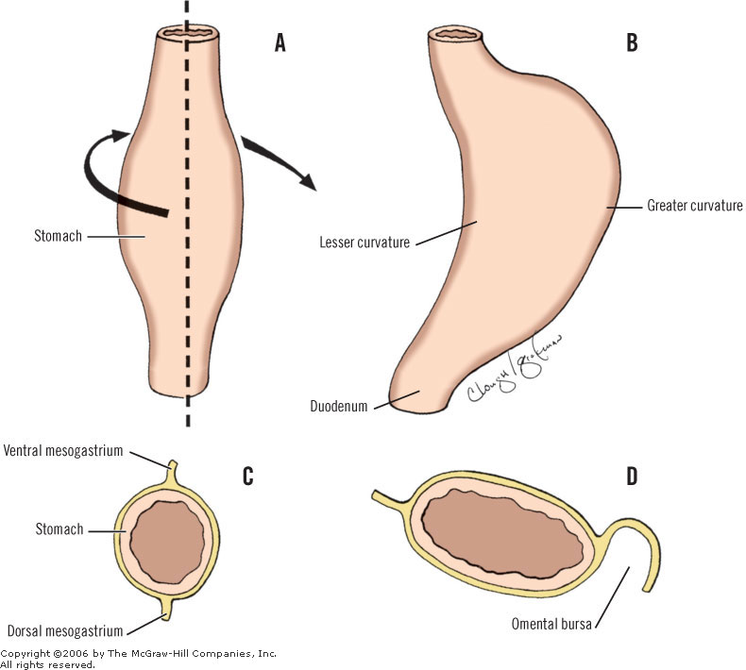

Rotation and Repositioning
Classical teaching (Moore/Sadler): The stomach undergoes two rotations:
- Longitudinal (anteroposterior) axis rotation — 90° clockwise:
  - The original dorsal border grows faster → becomes the greater curvature
  - The original ventral border grows slower → becomes the lesser curvature
  - Left vagus (originally posterior) → becomes anterior on the lesser curvature
  - Right vagus (originally anterior) → becomes posterior
- Craniocaudal axis tilt:
  - Cardia/fundus shift left and downward
  - Pylorus shifts right and upward
Contemporary view (O'Rahilly & Müller): Rather than true rotation, the apparent positional change may be explained entirely by differential growth of the two curvatures — the greater curvature simply grows faster and expands more. There is no compelling histological or imaging evidence for actual axial rotation. This explains the observations just as well without invoking a rotational mechanism.
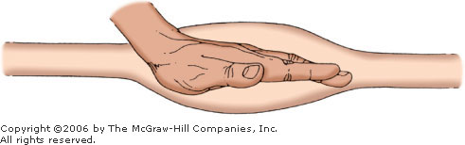
Location of left hand at embryonic foregut (beginning of dilated stomach). (Modified from Skandalakis JE, Gray SW (eds). Embryology for Surgeons, 2nd Ed. Baltimore: Williams & Wilkins, 1994)
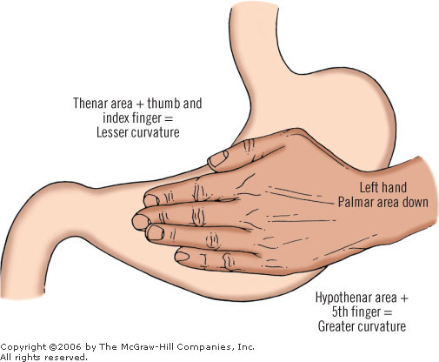
Use of left hand to demonstrate embryogenesis of stomach. Hypothenar and fifth finger touch the epigastrium vertically. If the same hand now turns so that the fifth finger and the hypothenar touch in a transverse way, the epigastrium and the palm in toto touch the epigastrium; then the fifth finger and hypothenar represent the greater curvature, and the thumb and index represent the lesser curvature. (Modified from Skandalakis JE, Gray SW (eds). Embryology for Surgeons, 2nd Ed. Baltimore: Williams & Wilkins, 1994)

Development of the curvatures
Feature | Lesser Curvature | Greater Curvature
Original position | Ventral midline | Dorsal midline
Growth rate | Slower | Faster
Concavity visible | 4th fetal month | —
Fundus outgrowth | — | 8th month
Vagal relation | Left (anterior) vagus | —

Histogenesis - timeline
Structure | Timing
Rugae | ~8th week
Muscularis | 8th–14th week
Glandular pits (lesser curvature first) | 6th–9th week
Glandular pits (entire stomach) | By 10th week
Parietal cells recognizable | ~11th week
Chief cells recognizable | ~12th week
Mucous cells | ~12th week
Pepsin in mucosa | Second half of 6th month
At birth | ~200,000 pits; ~500,000 glands

[CLINICAL] The sequence — parietal cells before chief cells — reflects the maturation order of the gastric unit. Parietal cells are the first functional secretory cells; HCl secretion begins in fetal life and has a role in amniotic fluid acidification and possible antimicrobial defence.

Molecular Basis
Foregut-stomach specification:
- SOX2 — expressed in the stomach endoderm; essential for gastric identity. SOX2 suppresses intestinal fate (CDX2). Loss of SOX2 → intestinal metaplasia of the stomach.
- BARX1 — mesenchymal transcription factor critical for stomach-specific identity; acts by repressing WNT signaling locally in the stomach region. BARX1 knockout mice develop an intestinalized stomach.
- WNT signaling — suppressed in the stomach region (by BARX1/sFRP); active in the intestine. This WNT suppression/activation boundary defines the gastroduodenal junction.
Gland & cell differentiation:
- Notch signaling — controls fate decisions between surface mucous cells and glandular cell types (parietal, chief, enteroendocrine)
- Sonic Hedgehog (SHH) — secreted from gastric endoderm; regulates mesenchymal patterning and gland morphogenesis
- NGN3 (Neurogenin-3) — required for enteroendocrine cell differentiation in the stomach
- MIST1 (BHLHA15) — transcription factor required for mature chief cell (zymogenic cell) identity; MIST1 knockout → chief cells fail to fully differentiate
- H⁺/K⁺-ATPase (ATP4A/ATP4B) — parietal cell proton pump; expressed from ~11th week, reflecting early functional maturation
Curvature/rotation patterning:
- Pitx2 — expressed asymmetrically on the left side; controls left-right asymmetry including gastric positioning
- Nodal/Lefty/Pitx2 cascade — the same left-right axis pathway that determines cardiac looping also positions the stomach; mutations cause situs inversus with gastric malposition

Clinical Correlations
Hypertrophic Pyloric Stenosis (HPS)
- Hypertrophy of the circular muscle layer of the pylorus, manifesting at 2–6 weeks of age
- Projectile, non-bilious vomiting → metabolic hypochloraemic hypokalaemic alkalosis
- Pathogenesis involves abnormal NOS (nitric oxide synthase) expression in the pyloric muscle → failure of relaxation; also linked to reduced IGF-1 and EGF signalling in the pyloric wall
- Associated with erythromycin use in neonates (motilin receptor agonist → pyloric spasm)
- Treatment: Ramstedt pyloromyotomy
Gastric Volvulus
- Abnormal rotation or laxity of gastric ligaments → stomach twists on itself
- Organoaxial (around long axis, most common) vs. mesenteroaxial
- Embryological basis: abnormal formation or laxity of the gastrosplenic and gastrophrenic ligaments (derivatives of the dorsal mesogastrium)
Gastroesophageal Reflux Disease (GERD) in neonates
- Immaturity of the lower oesophageal sphincter (LOS); the cardia has not fully descended to its subdiaphragmatic position
- Physiological in early infancy; pathological if associated with failure to thrive or oesophagitis
Congenital Microgastria
- Rare failure of stomach to expand from its fusiform primordium; presents as severe GERD, failure to thrive, recurrent aspiration
- Associated with asplenia and limb anomalies
Intestinal Metaplasia of the Stomach
- Loss of SOX2 expression and gain of CDX2 expression in gastric mucosa → gastric epithelium acquires intestinal characteristics
- Driven by H. pylori infection, bile reflux
- Pre-cancerous lesion → gastric adenocarcinoma (intestinal type)
- Direct embryological relevance: CDX2 normally suppressed in the stomach — its re-expression "reverts" cells to intestinal phenotype
Ectopic Pancreatic Tissue (Heterotopia)
- Pancreatic rest most commonly found in the stomach (antrum/pylorus), duodenum, or Meckel's diverticulum
- Results from misdirected differentiation of multipotent endodermal progenitors at the foregut-midgut junction
- Usually asymptomatic but can cause gastric outlet obstruction or bleeding
[WARNING]Key Points to Remember
- Differential growth (not rotation) most likely explains curvature formation — O'Rahilly & Müller are likely correct
- Parietal cells appear before chief cells (~11 vs ~12 weeks) — functional order matters
- Left vagus = anterior (lesser curvature); Right vagus = posterior — a direct consequence of stomach repositioning
- SOX2 vs CDX2 balance determines gastric vs intestinal identity — clinically relevant in metaplasia
- BARX1 is the key mesenchymal factor that makes the stomach a stomach (not intestine)
- Pyloric stenosis pathogenesis now understood to involve NOS deficiency, not just mechanical hypertrophy

